**Board Game Development - Application**

**Project Management Milestone1**

**Group-C**

**Project Title:**

Board Game Development

## **Description:**

This project is about developing a board game application for mobiles, laptop and computers. In this project we will build an application where everyone can play board games on their own machines with one click of installation, instead of physical board game. By this we can make a board game easy for everyone to play anywhere by inviting their friends who are far away from us and have fun with their loved ones.

#### **Team name:**

## DRAGONS

## **Team member names:**

1. Vineetha Yenugula
2. Tejaswi Reddy Kandula
3. Bharath Kumar Gandhasiri
4. Neelesh Saladi

**Client:** Tom Cruise

## **Team logo:**



## **Working as a team together:**

As a team we will take responsibility to complete the project on time with given budget along with this we will not compromise on quality.

## **Team meetings:**

We will meet daily at zoom calls and check if anyone has any issues and we will try to resolve this issues in the daily meet. Along with this we will also discuss on our future work.

## **Contacting each other:**

We will be communicating using Northwest Email, Zoom, and Skype for Business to have quick online meetings.

## **Dealing with a non-participating team member:**

As a team we will check whether the project is on track and if any team member is non-participating, we will try to resolve those issues by talking to him/her. If he/she is not interested in given work we will assign the work in which an individual is interested in.

|  |  |
| --- | --- |
| **Roles** | **Responsible Team members** |
| Team Lead | Bharath Kumar Gandhasiri |
| Game Engineer | Neelesh Saladi, Tejaswi Reddy Kandula,  Vineetha Yenugula |
| Application Developer | Tejaswi Reddy Kandula, Neelesh Saladi |
| Project Manager | Vineetha Yenugula |

## **Roles:**

**Project Manager and Team Lead**

* Arranging daily stand-up meetings
* Arranging Monday Sprint meetings
* Motivating Team
* Analyzing the scope
* Managing the risks
* Keeping track of all requirements
* Assigning tasks
* Communicating with other stakeholders
* Encouraging the team
* Providing guidance and instructions to team members

## **Game Engineer:**

* Developing and implementing game software
* Ensuring that the game design is fully implemented and performs as expected
* Designing, Creating and Developing game
* Creating unit tests and validation procedures, and documenting technical specifications
* Working closely with a lead game developer to create task/project deliverables
* Interface with Quality Assurance, Game Producers, Game Designers, Artists, Mathematicians, and Sound Designers

## **Application Developer:**

* Creating web application using various scripting languages and tools
* Meeting the requirements
* Meeting the given deadlines
* Time management

## **User interface developer:**

* Creating user interface for the website
* Communicating with other stakeholders
* Knowledge on different tools and technologies
* Meeting the requirement

Project Charter

Date: 05/15/2020

|  |  |  |  |
| --- | --- | --- | --- |
| **Project Title**: Board Game Development | | | |
| **Project Start Date:** 05/15/2020 **Projected Finish Date:** June 2020 | | | |
| **Budget Information:** Self-Funded | | | |
| **Project Manager:** Vineetha Yenugula, S538313@nwmissouri.edu | | | |
| **Project Objectives:** To develop a board game by providing user-friendly application and make its availability easy for everyone at anywhere without in need of physical board game. | | | |
| **Success Criteria:**Before the deadline we the expert team of game engineers will finish our board game application with a competence and skills which we need for the successful completion of our project with a bug free, user friendly design and it will be on live with Good Implementation. | | | |
| **Approach:**  **AGILE APPROACH** | | | |
| **Roles and Responsibilities** | | | |
| ***Name and Signature*** | ***Role*** | ***Position*** | ***Contact Information*** |
| 1. Bharath Kumar Gandhasiri | Team Lead | Team Lead | S538366@nwmissouri.edu |
| 1. Neelesh Saladi | Game Engineer/ Application Developer | Team Member | S538300@nwmissouri.edu |
| 1. Tejaswi Reddy Kandula | Game Engineer/ Application Developer | Team Member | S538309@nwmissouri.edu |
| 1. Vineetha Yenugula | Project Manager/Game Engineer | Project Manager | S538312@nwmissouri.edu |
|  | | | |
| **Comments:** (Handwritten or typed comments from above stakeholders, if applicable) | | | |

Stakeholder Register for Board Game Development

**Prepared by:** Vineetha Yenugula **Date: 05/15/2020**

|  |  |  |  |  |
| --- | --- | --- | --- | --- |
| **Name** | **Position** | **Internal/External** | **Project Role** | **Contact Information** |
| Bharath Kumar Gandhasiri | Team Lead | Internal | Team Lead | S538366@nwmissouri.edu |
| Neelesh Saladi | Team Member | Internal | Game Engineer/ Application Developer | S538300@nwmissouri.edu |
| Tejaswi Reddy Kandula | Team Member | Internal | Game Engineer/ Application Developer | S538309@nwmissouri.edu |
| Vineetha Yenugula | Project Manager | Internal | Game Engineer/ Project Manager | S538312@nwmissouri.edu |
| Tom Cruise | Client | External | End User | tomcruise@nwmissouri.edu |

**Signatures:**

Bharath Kumar Gandhasiri:

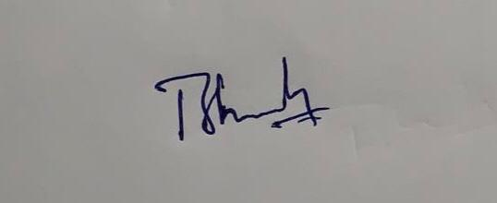

Neelesh Saladi:

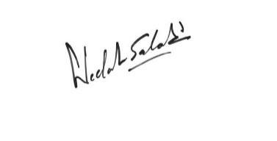

Tejaswi Reddy Kandula:

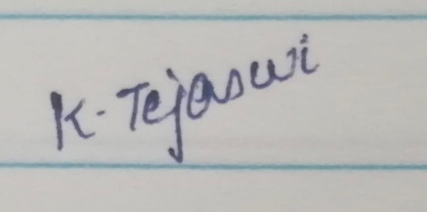

Vineetha Yenugula:

